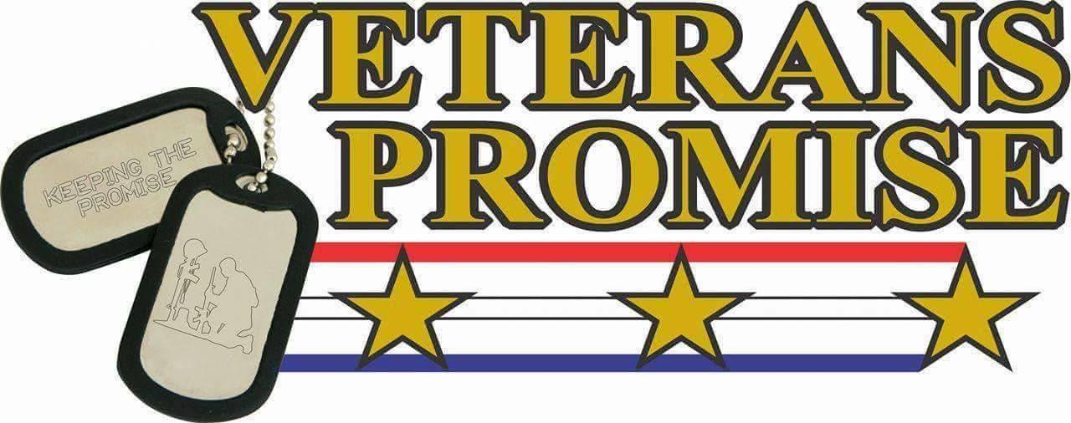

Friends & Supporters,

Our Promise Keepers Golf Tournament fundraiser will be held this year on Sunday 25 August 2024 at Veterans Promise Shadow brook resort Tunkhannock PA. In order to ensure the success of this fundraiser, we are seeking contributions from our local community in the form of a basket donation or gift certificates for our raffle.

Generous donors like you are the key to our success and continue to make it possible for Veterans Promise to continue our mission to assist & advocate for Veterans and their families, in obtaining services, support and raising awareness for Veteran suicide prevention. Whatever it takes!

Your donation will be listed at our event, as well as on our public Facebook page.

Please contact Peter Sehne 570-241-8102 , Dave Ragan 570-766-3435 or Dennis Dolan 570-237 2164, message us via Facebook or email us directly at veteranspromise22@gmail.com to make a donation. We appreciate your continued support as we help Veterans and their families all over Pennsylvania.

Thank you for helping us KEEP THE PROMISE!

Veterans Promise Executive Board & Advocates

Veteran’s Promise NEPA

veteranspromise22@gmail.com

737 Main Street

570-892-2060

Dickson City, PA 18519

501c3 EIN#81-4486826